CHAPTER 4: Chemical patterns

Worksheet 4.5

Ionic bonding
Answers

Ions forming stable electron configurations
1. When atoms form ions by losing or gaining electrons, they do so to produce a full outer shell, which gives the atom a stable electron configuration. The noble gases are non-reactive because they have a full outer shell.
Complete the following table by showing that each ion has a stable noble gas configuration in its valence (outer) shell.
Atom | Electron configuration | Ion | Electron configuration
F | 2, 7 | F– | 2, 8
N | 2, 5 | N^{3–} | 2, 8
Al | 2, 8, 3 | Al³⁺ | 2, 8
K | 2, 8, 8, 1 | K⁺ | 2, 8, 8
S | 2, 8, 6 | S^{2–} | 2, 8, 8
Br | 2, 8, 18, 7 | Br– | 2, 8, 18, 8

Forming an ionic compound
2. The electron shell diagram below shows how a lithium atom and a fluorine atom combine to form lithium fluoride.
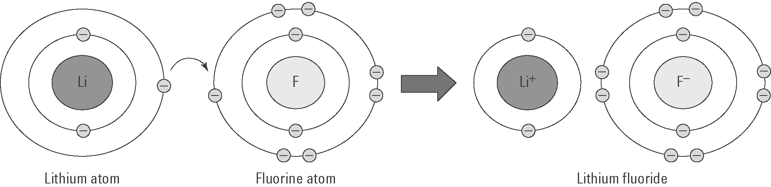
Using similar diagrams, show how the compound beryllium oxide forms when a beryllium atom
(2, 2) and an oxygen atom (2, 6) react.
